ACTIVITÉS: L'heure /

Quelle heure est-il?

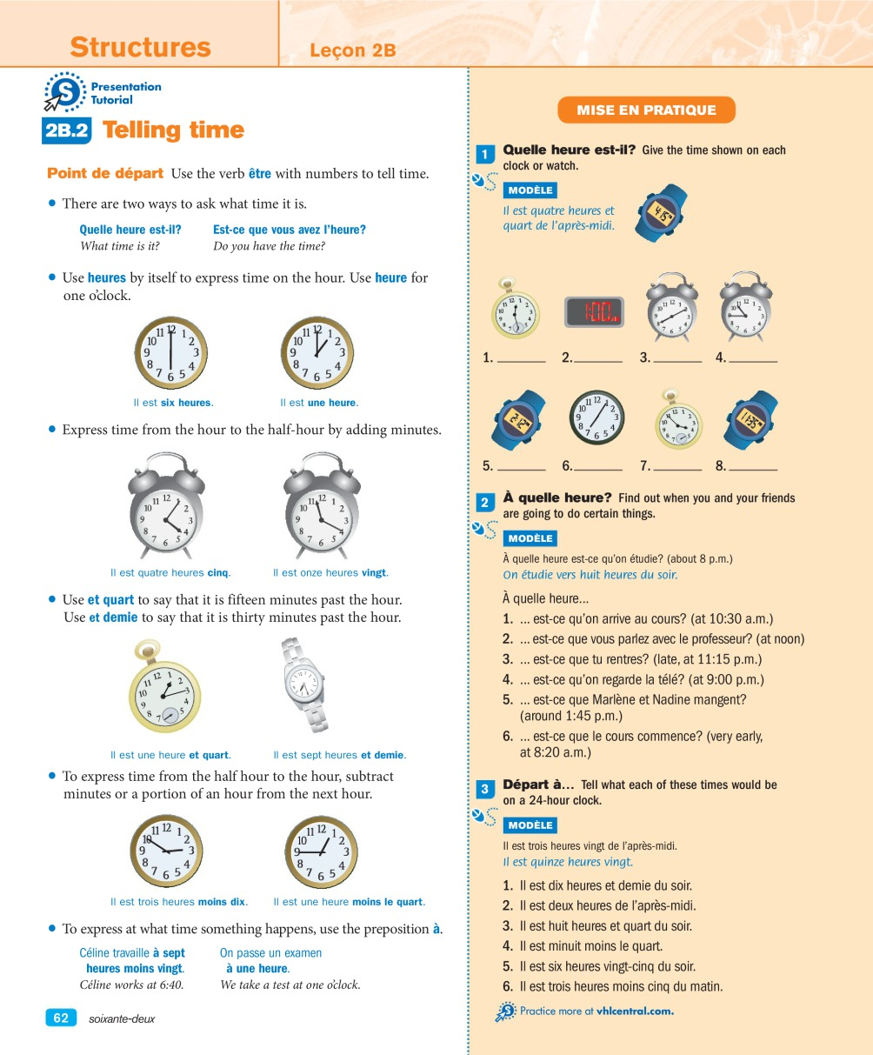

## 1 - L'heure

**Give the time shown on each clock. Use complete sentences and write out the times. Do not use the 24-hour clock.**

### Questions

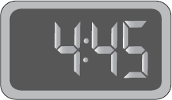**________________________________________________________________**

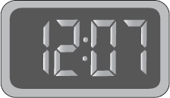

**________________________________________________________________**

###### It is seven fifty-eight **________________________________________________________________**

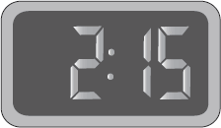

**________________________________________________________________  
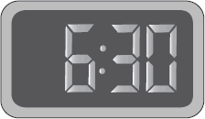**

**_______________________________________________________________  
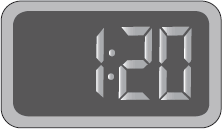  
  
______________________________________________________________**

## 

## 

## 

## 2 - Quelle heure est-il?

### Instructions

**Convert each time into digits using the 24-hour clock.**

### Questions

**Modèle**

**Il est quatre heures de l'après-midi. 16h00**

1. Il est quatre heures moins vingt de l'après-midi. _________________________________________________________________
2. Il est six heures du matin. _________________________________________________________________
3. Il est neuf heures et quart du soir. _________________________________________________________________
4. Il est midi. _________________________________________________________________
5. Il est une heure dix de l'après-midi. _________________________________________________________________
6. Il est onze heures moins le quart du matin. _________________________________________________________________
7. Il est cinq heures cinq du soir. _________________________________________________________________
8. Il est minuit moins dix. _________________________________________________________________
9. Il est une heure et demie du matin. _________________________________________________________________
10. Il est dix heures du soir. _________________________________________________________________

## 3 - Transformez

### Instructions

Convert each time into conversational time using expressions such as **de l'après-midi** and **du soir**. Follow the model and write out the times.

### Questions

**Modèle:** 13h00: **une heure de l'après-midi**

1. 13h10: _________________________________________________
2. 07h45: ________________________________________________
3. 22h50: ________________________________________________
4. 09h15: ________________________________________________
5. 18h40: ________________________________________________
6. 03h05: ________________________________________________
7. 15h30: ________________________________________________
8. 12h30: ________________________________________________

## 

## 4 - Dans cinq minutes

### Instructions

Look at the clocks below and tell what time it will be in five minutes. Do not use the 24-hour clock. Write out the times. Follow the model.

### Questions

**Modèle** 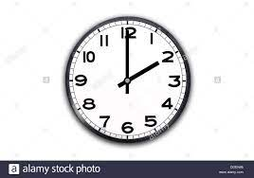

**deux heures cinq**

1. 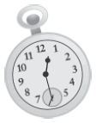**------------------------------------------------**
2. 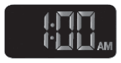**--------------------------------------------**
3. 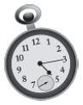**--------------------------------------------------**
4. 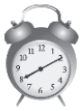**---------------------------------------------------**
5. 