Leçon 6A.1

GRAMMAR QUIZ II
Demonstrative adjectives

1 |  | Écrivez Write a statement, description, or opinion about each item using a demonstrative adjective.  (5 x 1 pt. each = 5 pts.)

Modèle
Yale
Mon frère va visiter cette université.

1. |  | Michael Jackson
2. |  | La Joconde (Mona Lisa) de Léonard de Vinci
3. |  | Paris
4. |  | le football
5. |  | Spiderman et X-Men

2 |  | Imaginez Write a sentence about each picture using a demonstrative adjective. (4 x 2 pts. each = 8 pts.)

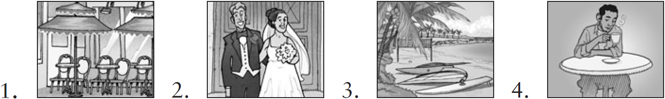

1.
2.
3.
4.

3 |  | À une fête You are at a party with your best friend. Write a conversation in which the two of you  comment on the guests, the food, and the drinks. Use as many demonstrative adjectives as possible.  (5 pts. for grammar + 2 pts. for creativity = 7 pts.)

